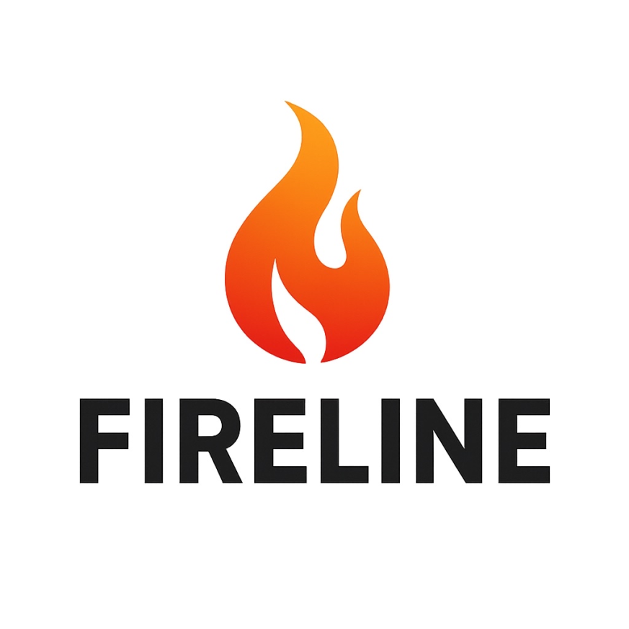

**Fireline**

***Contents***

Assignment2

Team2

Stages of development3

Project description4

Block diagram 5

Functions6

**Assignment**

This project involves designing a web-based information system for fire safety in a specific region, using HTML, CSS, and JavaScript. The system should manage data about fire stations, employees, fire trucks, and incidents, allowing real-time reporting, team coordination, and data visualization through interactive maps and statistical charts.

**Our Team:**

|  |  |  |
| --- | --- | --- |
| № | Name and class | Role |
| №1 | Roberta Hristova– 9B | Scrum trainer |
| №2 | Daniil Moldovanov – 9G | Back-end developer |
| №3 | Konstantinv Turmanov – 9A | Front-end developer |
| №4 | Ameliq Dorosh – 9A | Designer |

**Stages of development**

|  |  |
| --- | --- |
| № | Stage |
| 1 | **Assembling the team**  We gathered and distributed the roles, so each person can work on the field that he is most competent with. |
| 2 | **Idea**  We decided to make a fire helping based platform. We started thinking of an idea for it, and decided on making a incident report as well as team to respond to the incident |
| 3 | **The process of creating the product**  Every week there were meetings to discusses the progress and the tasks that are left. We assigned each task to the person that we believed can do it quickly, clearly, and accurately, so the team would be more productive and efficient. |
| 4 | **Polishing the product**  After we finished with the project and the documentation, we fixed some bugs and made the overall user experience a bit more pleasant. |
| 5 | **Presenting the product**  After weeks of hard working and restless nights we finished the project and it is now ready to be presented. |

**Project description**

|  |  |
| --- | --- |
| № | Description |
| 1 | **A general idea about the project**  **Fireline** is a web application designed to track, manage, and visualize incidents. The project simulates an emergency response system that includes features like maps, statistics, teams, vehicles, and contact forms. Its main goal is to demonstrate how such critical information can be digitally organized and presented. |
| 2 | **How to access our project**  The project can be accessed by opening the index.html file after cloning or extracting the repository. GitHub repository: <https://github.com/codingburgas/9th-grade-html-project-fireline> |
| 3 | **Team work**  The project was a team effort divided among four members with specific roles:   * **Scrum Trainer** – managed tasks and workflow * **Frontend Developer** – built the user interface * **Backend Developer** – implemented logic using PHP * **Designer** – handled visual style and layout   Communication was mainly done via Microsoft Teams. |
| 4 | **Used technologies for our project development**  **Languages:** HTML, CSS, JavaScript, PHP  **Tools:** Visual Studio Code, GitHub  **Communication:** Microsoft Teams  **Documentation & Presentation:** Microsoft Word and PowerPoint |

**Block diagram**

